**What is compression?**

* Data compression tries to encode information in such a way that it takes up less space / bits
* There is Lossless Compression, where all the data is preserved (useful for example when sending zip files)
* Then there is Lossy Compression, where some data is thrown away in an effort to make the file size smaller (ex. In image compression)

**Huffman Encoding**

* Huffman Encoding is a form of Lossless compression
* Huffman Encoding works by encoding commonly found characters in less bits (ex. A = 010) and less common letters in more bits (ex. Z = 0111010)
* To find the optimal encoding format, we need to build a huffman tree by arranging all the letters in descending order of how common they appear
  + Then you assemble the tree by going from the least common letters and combining them

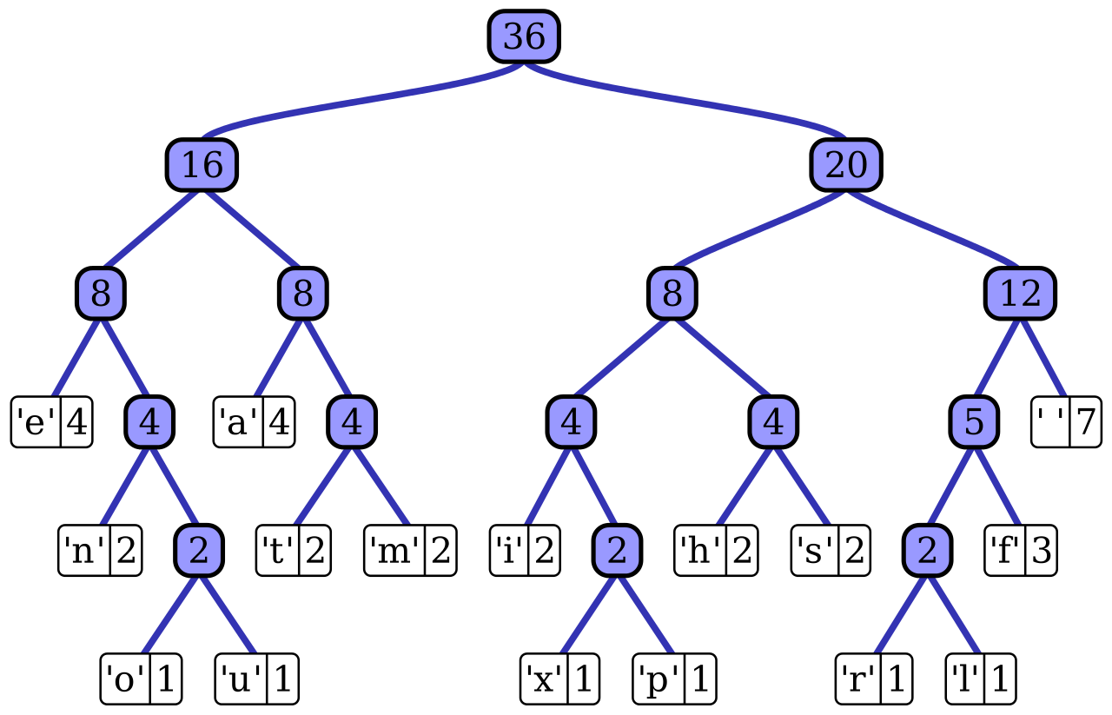

**Structure of Program**

* The program works by first reading in a file and storing all the characters in a Doubly-Linked List and sorting each element as a character “weight” (# of occurrences) is incremented
* The program then starts from the back of the linked list and assembles the two least common nodes into a node and resorts the linked list
  + Carry this on until the linked list is only composed of one node, which contains a tree with all of the characters
* After we get the Huffman Tree, it is just a matter of traversing the tree to decode / encode letters
  + In my code, to speed things up I create a map which links all of the characters to their corresponding Huffman Code

Sample Output:

Enter input file name ( 0 for default: in.txt ): 0

MENU OPTIONS:

1. Print Character Weights

2. Print Tree

3. Print Huffman Code for All Character

4. Print Huffman Code for a Character

5. Print Huffman Code for a Word

6. Decode An Encoded Word

7. Encode File

8. Decode File

9. Exit

1

' ' (DEC32): 3

'!' (DEC33): 1

'C' (DEC67): 1

'I' (DEC73): 1

'L' (DEC76): 1

'P' (DEC80): 1

'a' (DEC97): 1

'e' (DEC101): 1

'g' (DEC103): 2

'i' (DEC105): 1

'm' (DEC109): 2

'n' (DEC110): 1

'o' (DEC111): 2

'r' (DEC114): 2

'v' (DEC118): 1

MENU OPTIONS:

1. Print Character Weights

2. Print Tree

3. Print Huffman Code for All Character

4. Print Huffman Code for a Character

5. Print Huffman Code for a Word

6. Decode An Encoded Word

7. Encode File

8. Decode File

9. Exit

3

Select an option:

1. Print All Characters

2. Print All Alpha Characters

3. Print All Characters with Weights

3

' ' (DEC32): 010

'!' (DEC33): 10110

'C' (DEC67): 00110

'I' (DEC73): 00010

'L' (DEC76): 00011

'P' (DEC80): 00111

'a' (DEC97): 00100

'e' (DEC101): 00001

'g' (DEC103): 100

'i' (DEC105): 00101

'm' (DEC109): 111

'n' (DEC110): 1010

'o' (DEC111): 011

'r' (DEC114): 110

'v' (DEC118): 00000

MENU OPTIONS:

1. Print Character Weights

2. Print Tree

3. Print Huffman Code for All Character

4. Print Huffman Code for a Character

5. Print Huffman Code for a Word

6. Decode An Encoded Word

7. Encode File

8. Decode File

9. Exit

5

Enter a word: CProg!

ASCII REPERSENETATION: 010000110101000001110010011011110110011100100001

HUFFMAN CODE: 001100011111001110010110

MENU OPTIONS:

1. Print Character Weights

2. Print Tree

3. Print Huffman Code for All Character

4. Print Huffman Code for a Character

5. Print Huffman Code for a Word

6. Decode An Encoded Word

7. Encode File

8. Decode File

9. Exit

6

Enter an encoded word in binary: 001100011111001110010110

CProg!